**DBMS LAB-05(16-01-2025)**

**Name-** Bhavya Shrivastava **Roll No-** 23052071 **Section-** CSE-15

**1. Find the average salary of each department.**

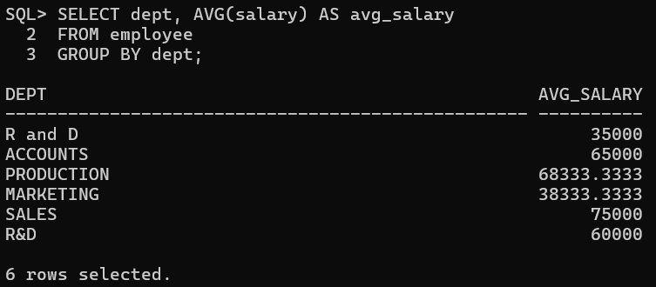**2. Find the average salary for each jobtype according to each department.**

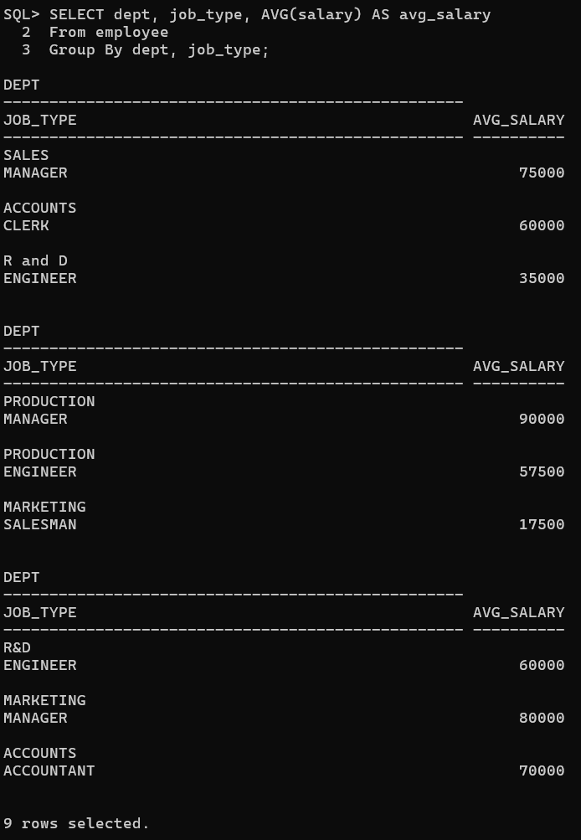

**3. Find the department names and their corresponding average salary where the average**

**salary is greater than 40000.**

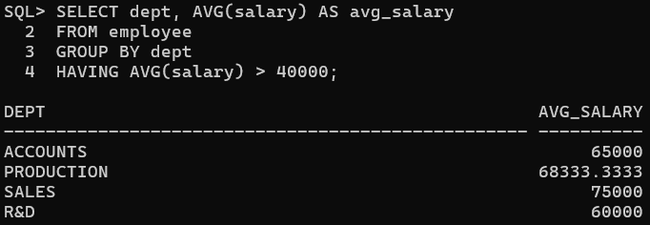

1. **Select the departments where the maximum salary is more than 55000.**

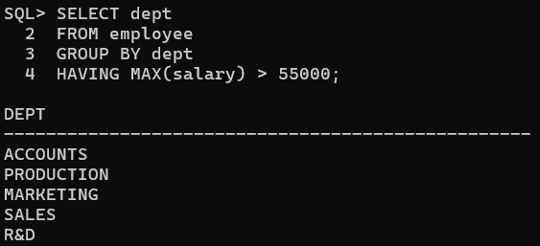

**5. Find the department names and their average salary where the maximum salary of the**

**department is higher than 55000.**

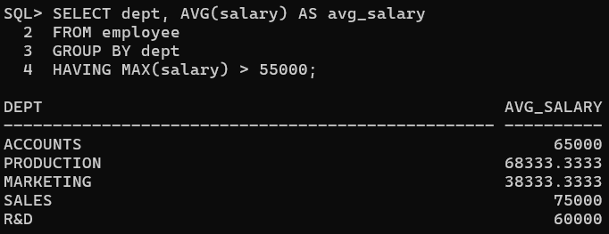

**6. Display the job_types and the total monthly salary for each jobtypes as “PAYROLL”, where**

**the total payroll according to jobtypes exceeds 100000/month.**

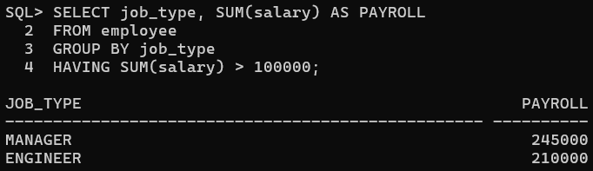

**7. Display the job_types and the total monthly salary for each jobtypes as “PAYROLL”, where**

**the total payroll according to jobtypes exceeds 100000/month and jobtype is not engineer.**

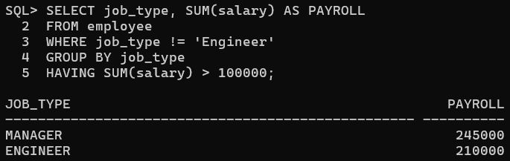

**8. Display the job_types and the total monthly salary for each jobtypes as “PAYROLL”, where**

**the total payroll according to jobtypes exceeds 60000/month and jobtype is not engineer**

**and sort the list in ascending order of sum of salary.**

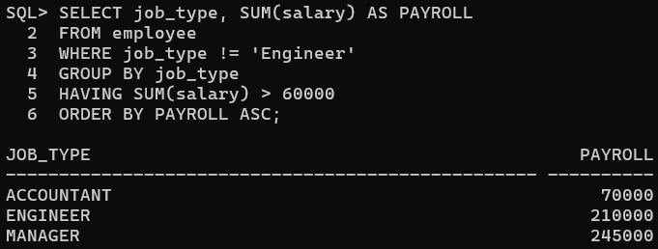

**9. Display the job_types and the total monthly salary for each jobtypes as “PAYROLL”, where**

**the total payroll according to jobtypes exceeds 50000/month and jobtype is not engineer**

**and sort the list in descending order of sum of salary.**

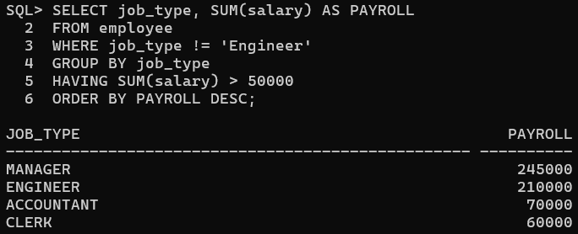

1. **Find the maximum average salary according to departments.**

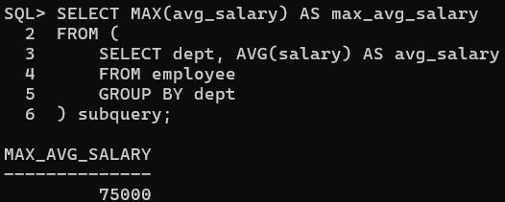

1. **Find the minimum average salary according to jobtypes.**

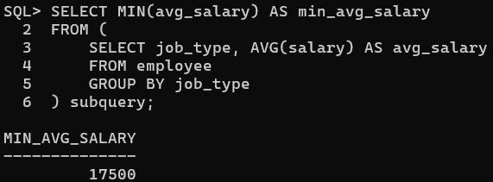

1. **Find the employee name and date of joining who are working in delhi.**

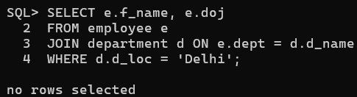

**13. Create the table ‘Emp_Address’ for storing the permanent address of the employees and**

**insert the values.**

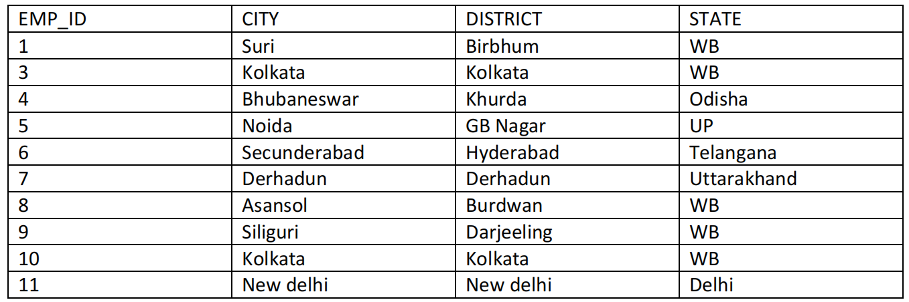

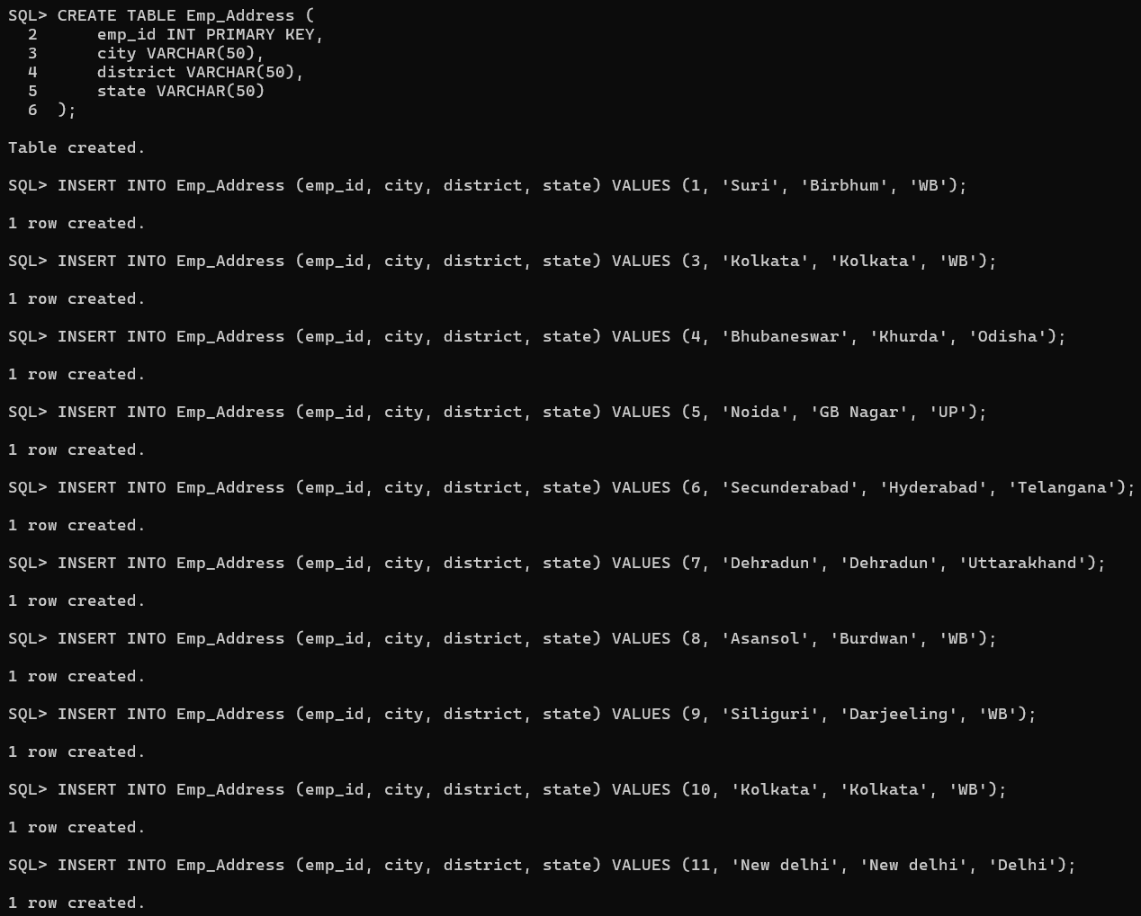

**14. Display the employee name with their home city and the city they work in.**

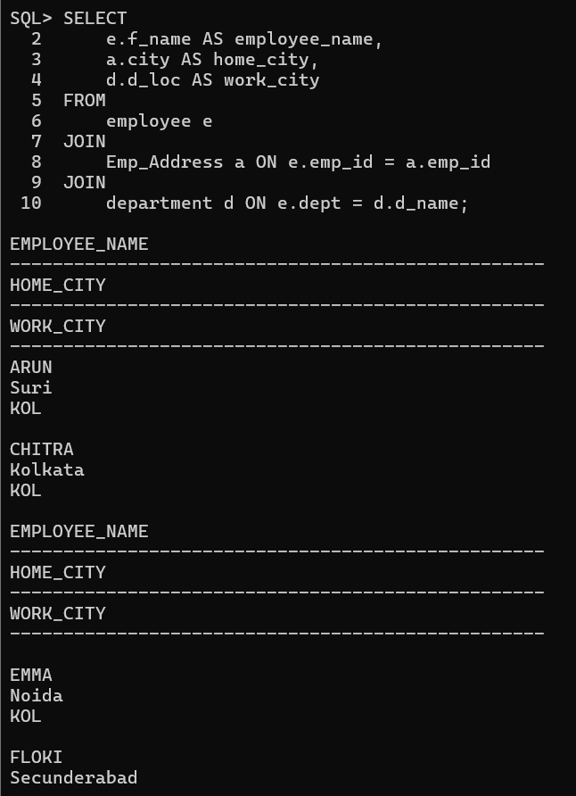

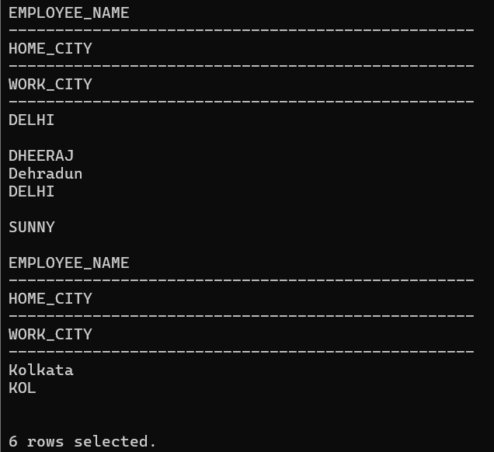

1. **Create the following Job_Grades table.**



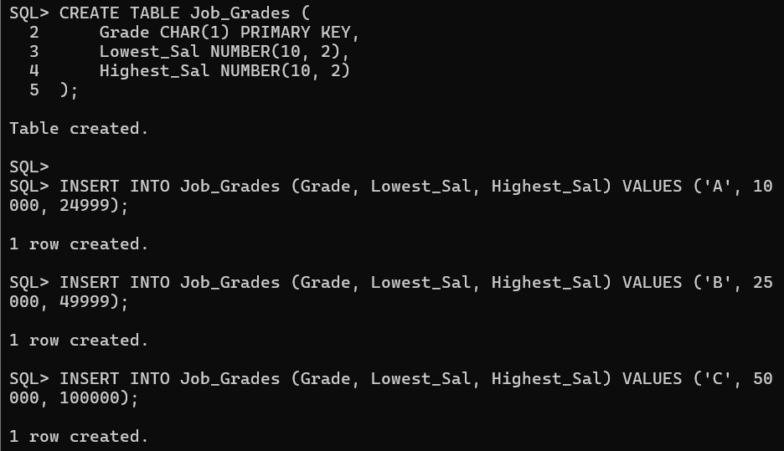

1. **Display the employee names along with their salary and job_grade.**

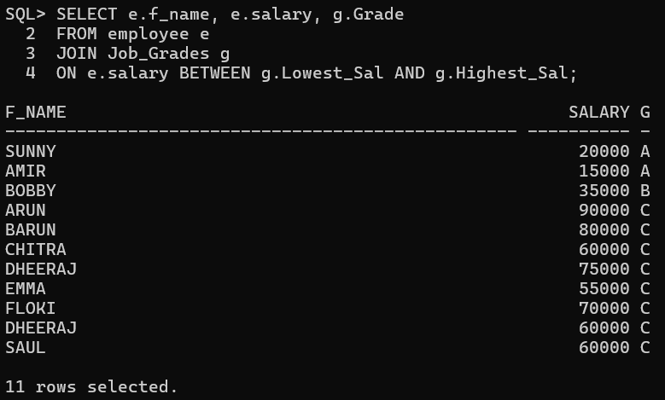

1. **Display the employees name along with their manager’s name. (use SELF JOIN)**

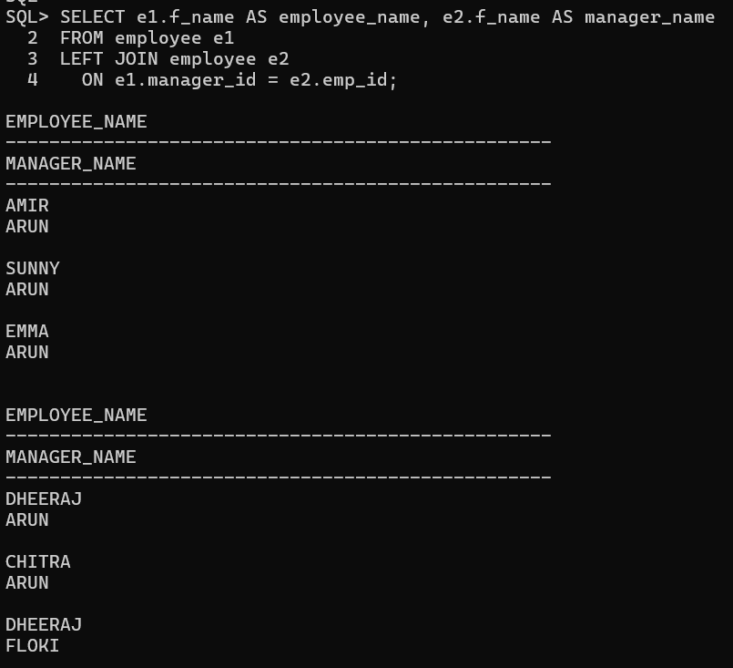

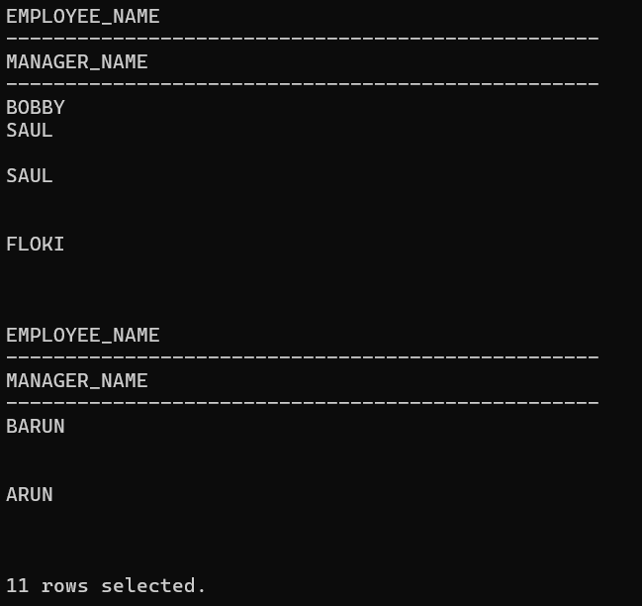

1. **Display emp_id, f_name, d_loc, and hod_id (using natural join).**

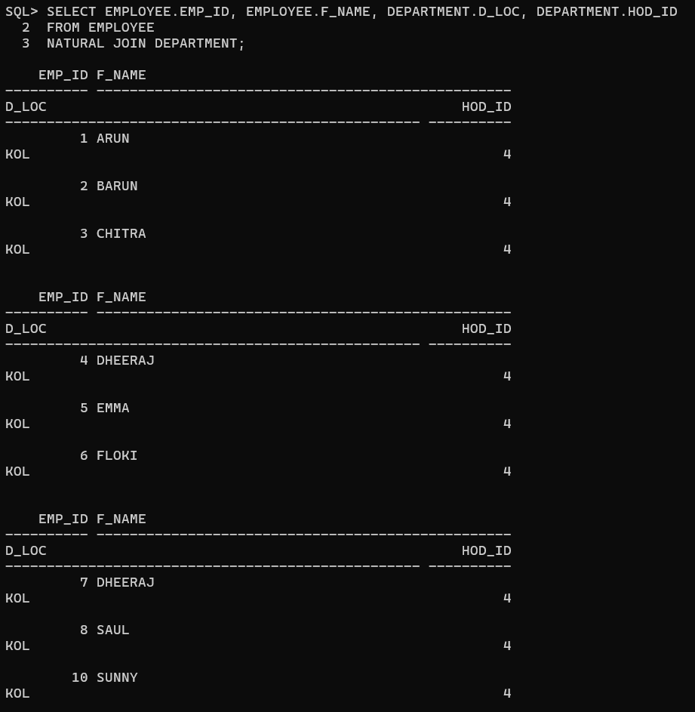

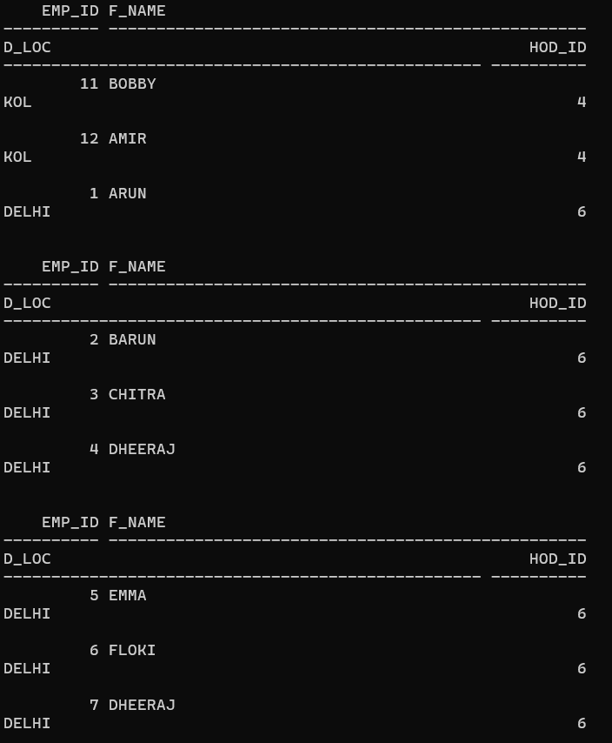

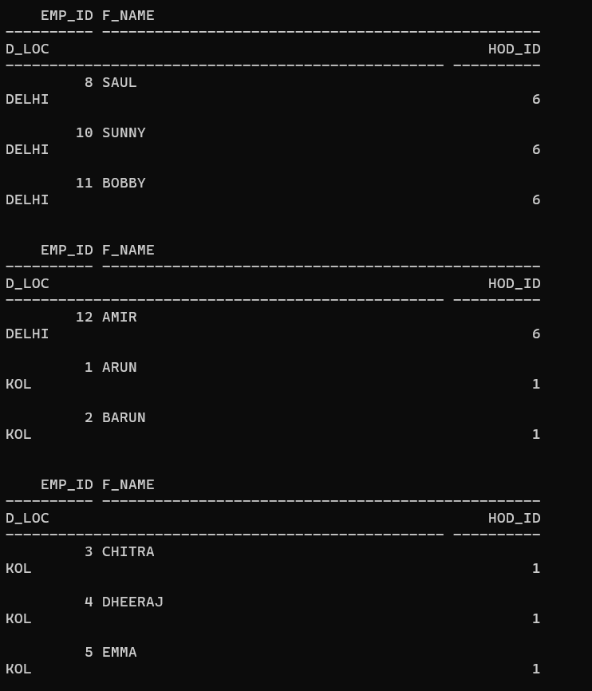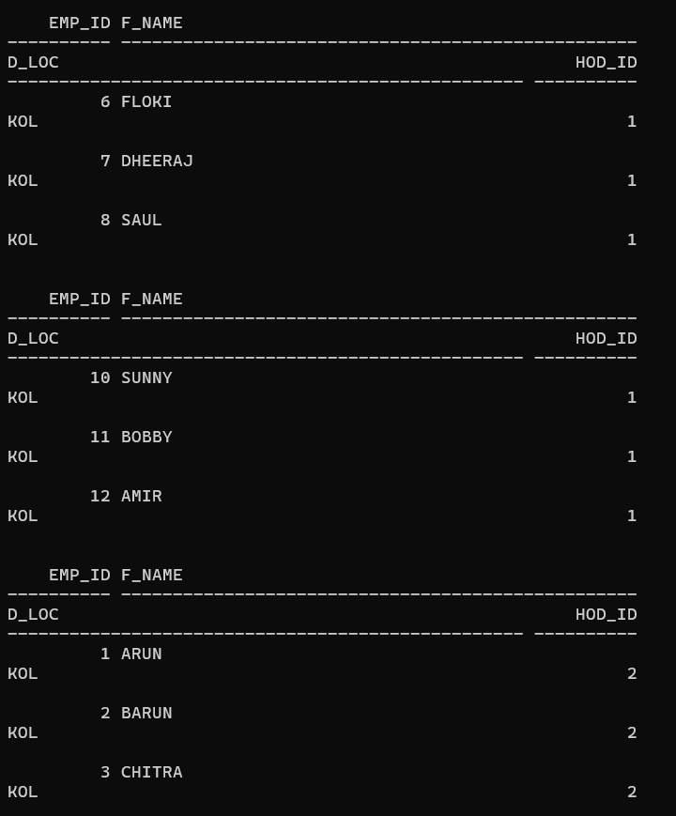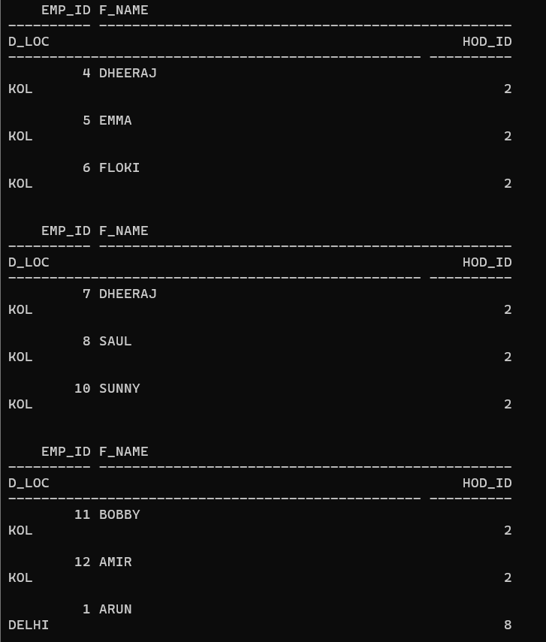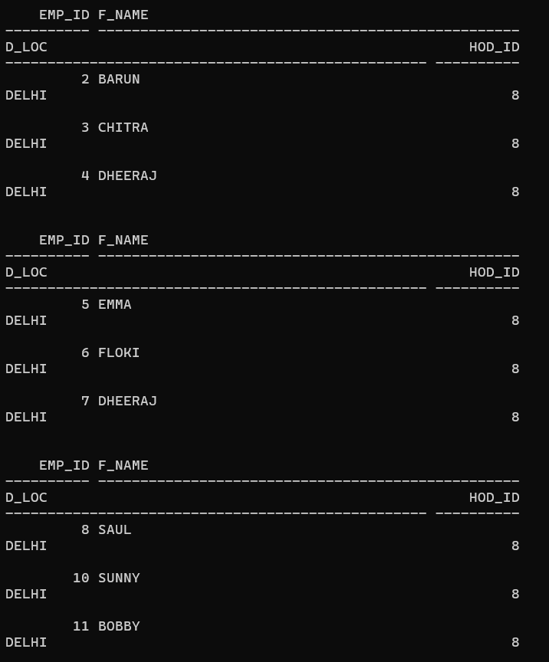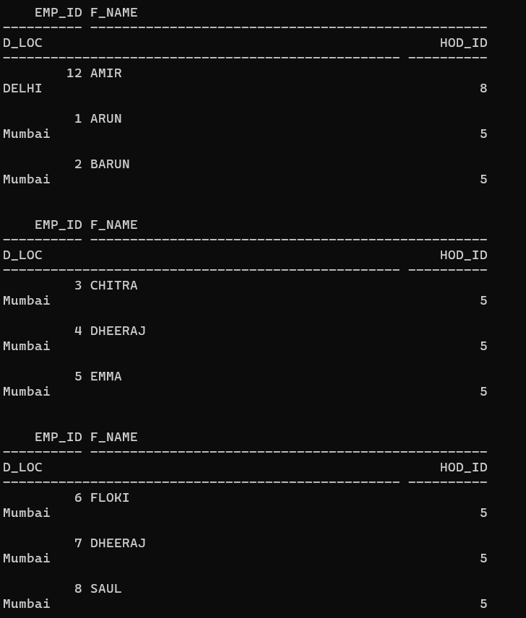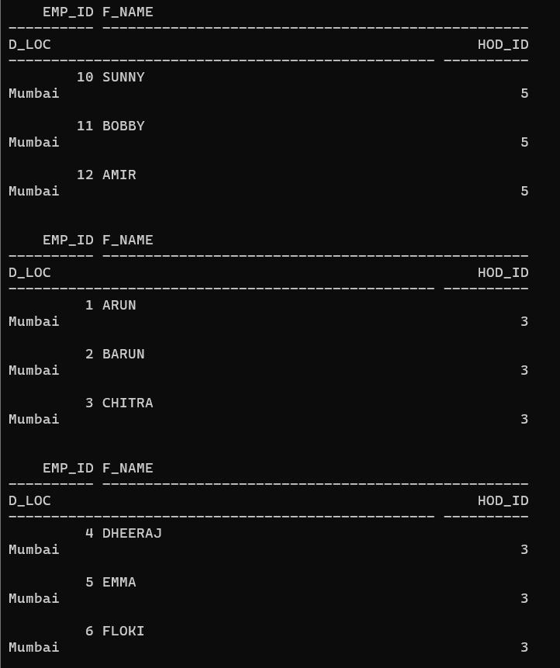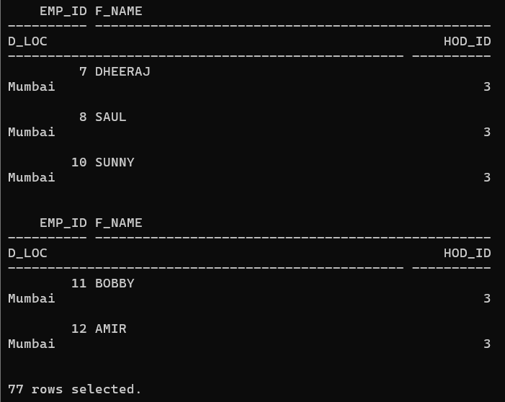

1. **Display the employees f_name, city and state in which they live (using natural join).**

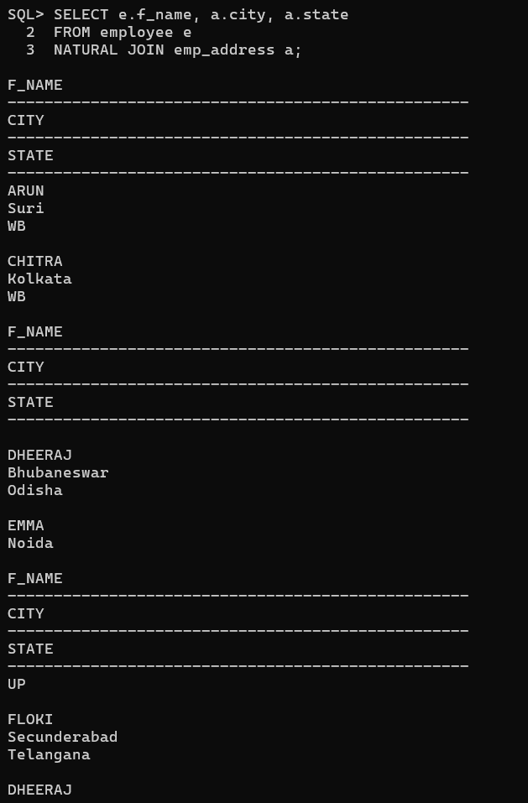

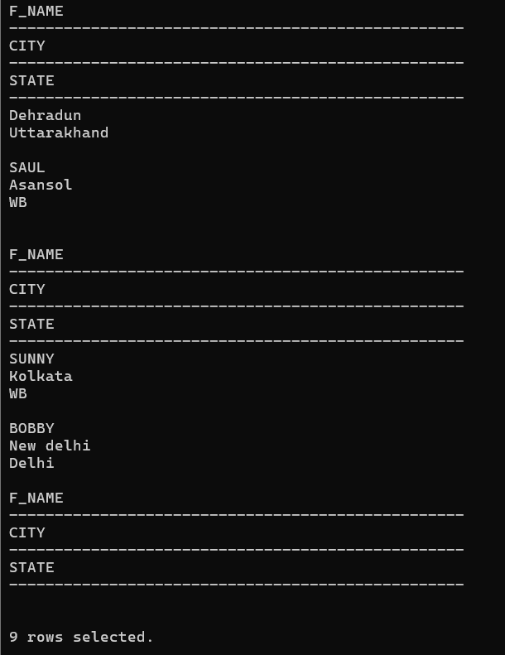

1. **Display the employees emp_id, f_name, d_loc, hod_id using inner join.**

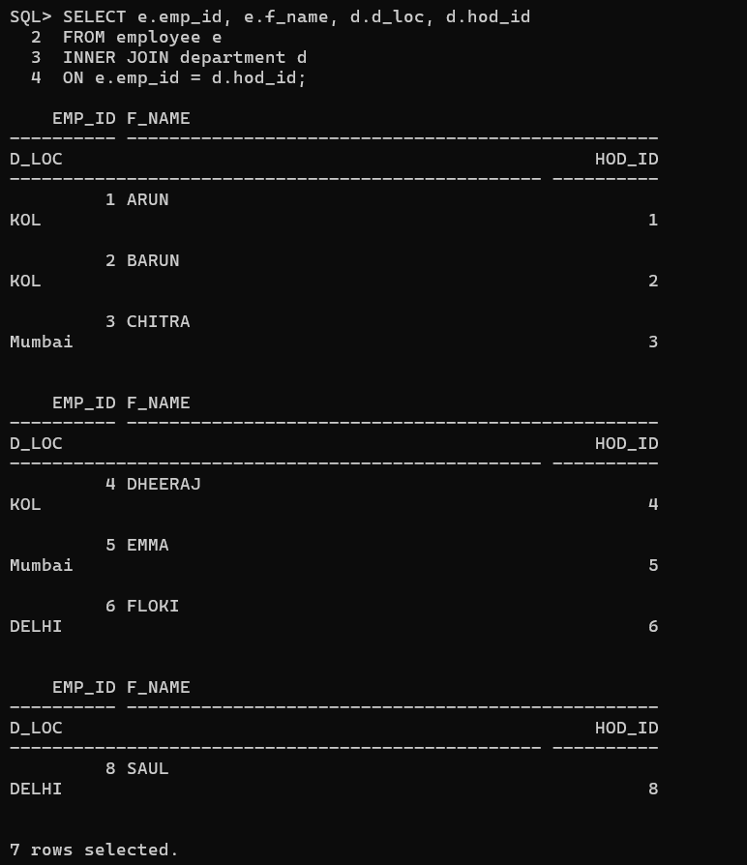

1. **Display the employees f_name, city and state in which they live (using inner join).**

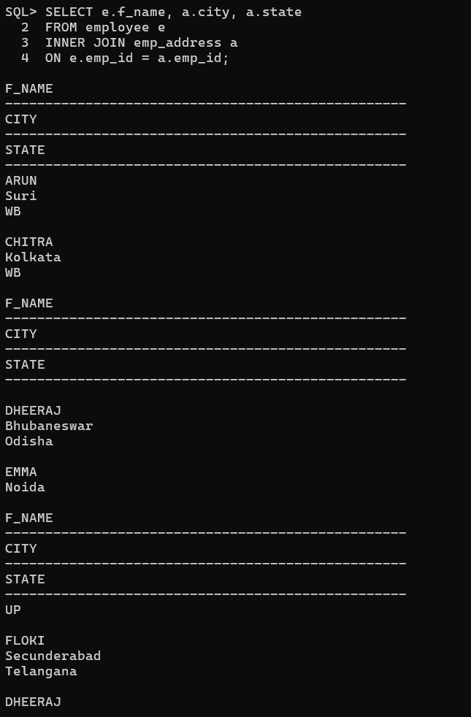

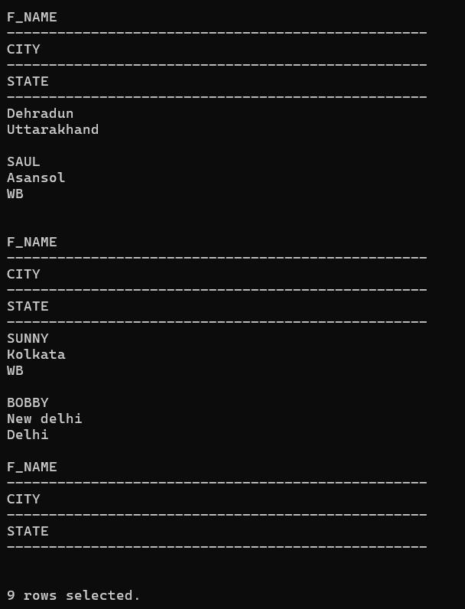

1. **Display the employees f_name, city and state in which they live (using join keyword).**

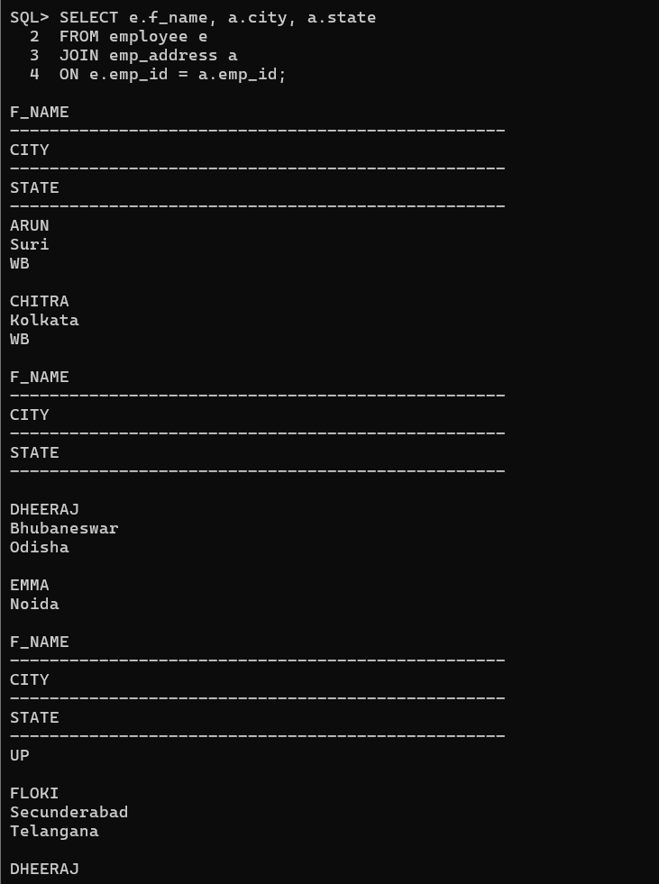

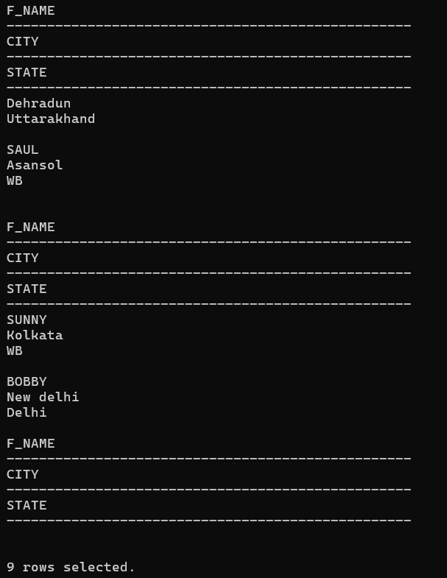

**23. Insert the following two rows in the employee table without inserting any value in the**

**department field.**

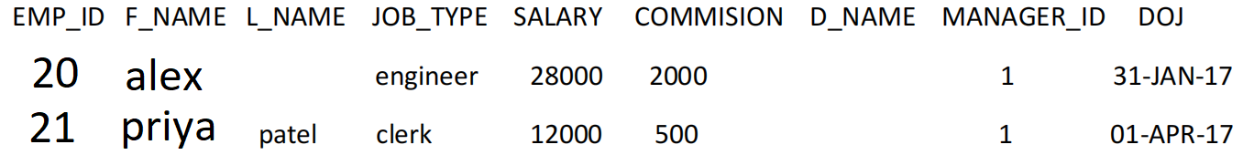

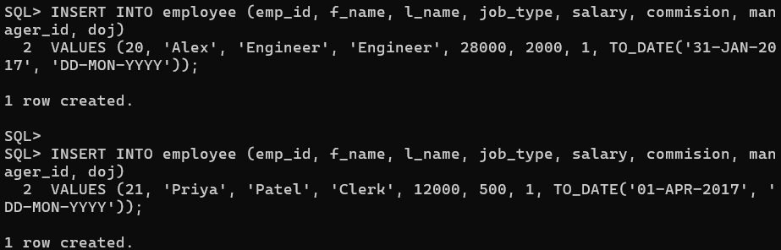

1. **Insert the following two rows into the department table.**

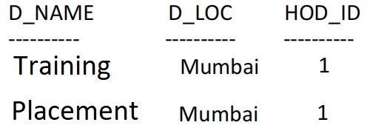

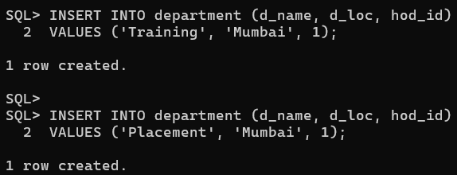

**25. Display the employees f_name, city and state in which they live after joining employee**

**and employee_address table using left outer join.**

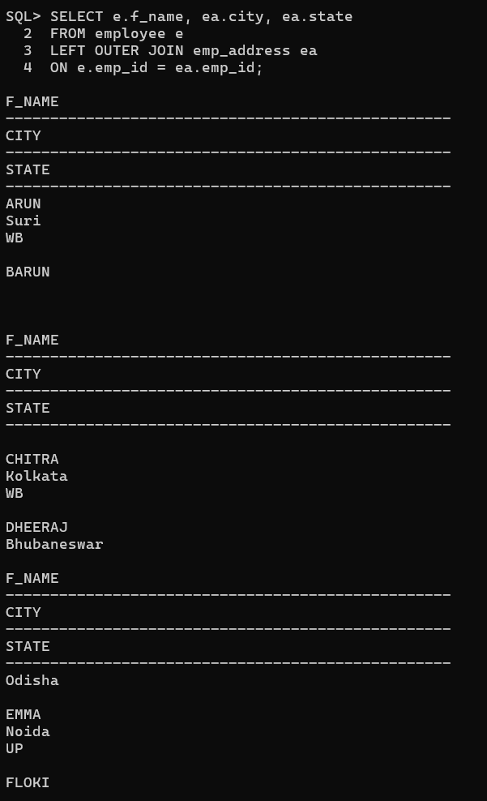

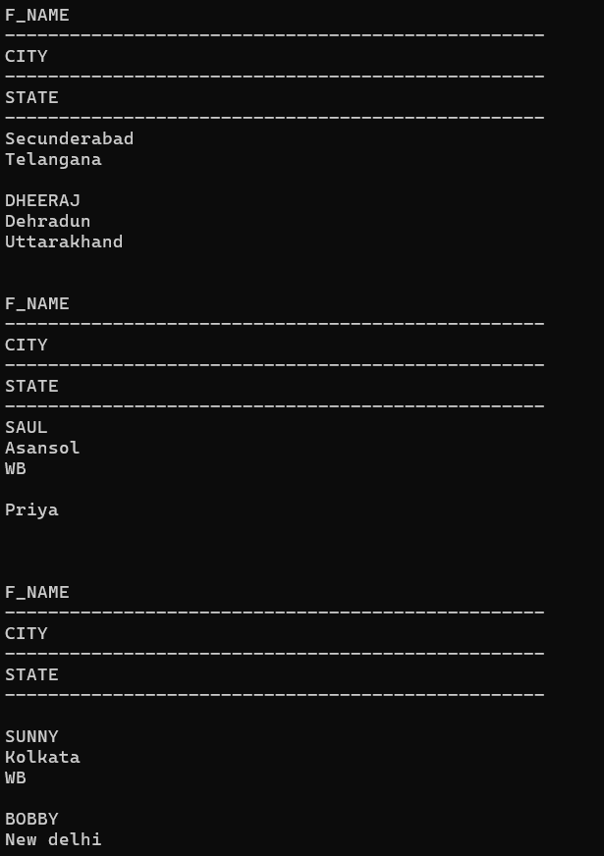

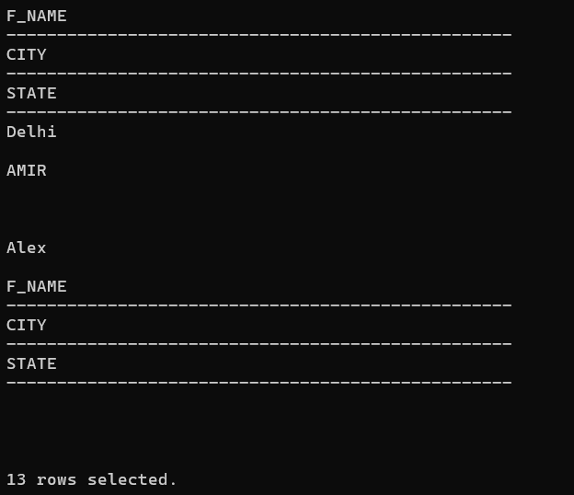

**26. Display the employees f_name and their work location after joining employee and**

**department table using left join.**

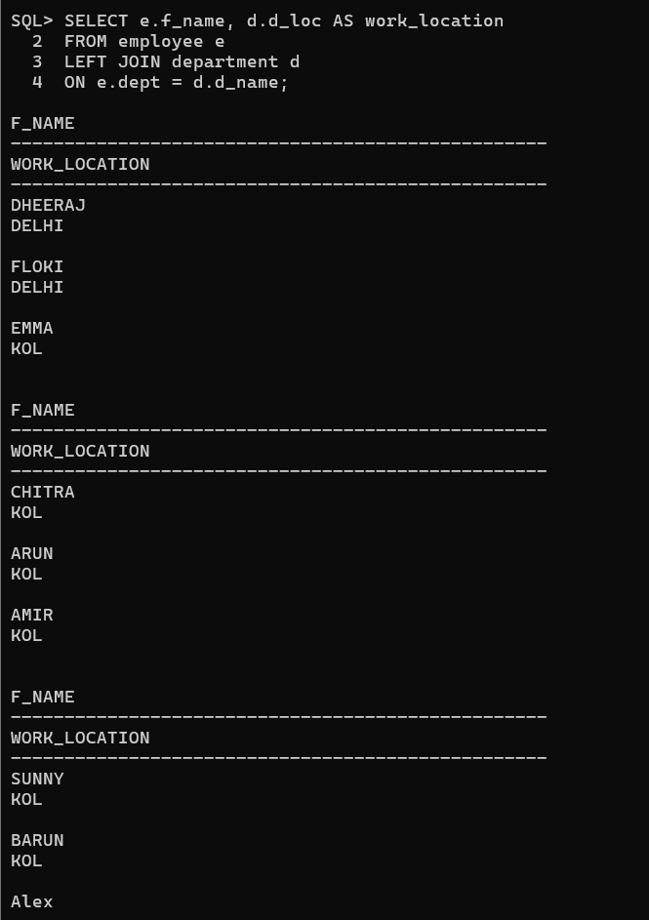

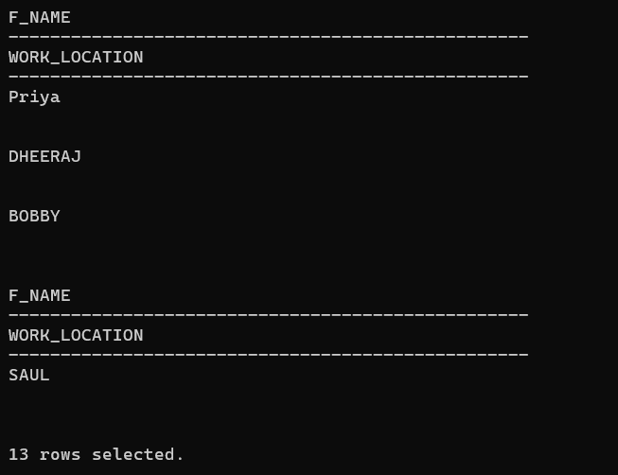

**27. Display the employees f_name and their work location after joining employee and**

**department table using right join.**

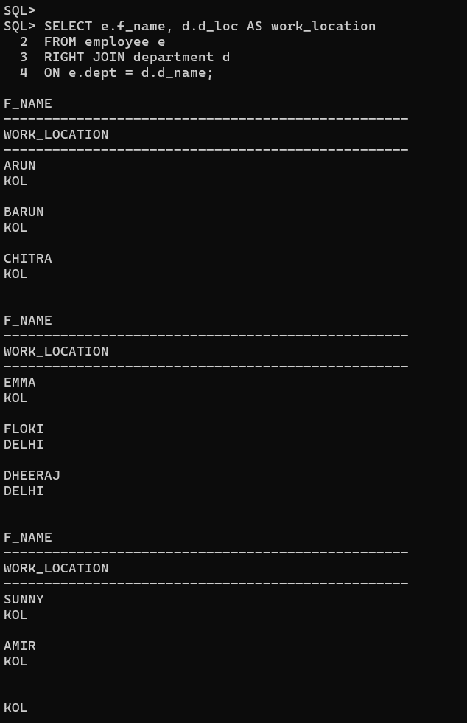

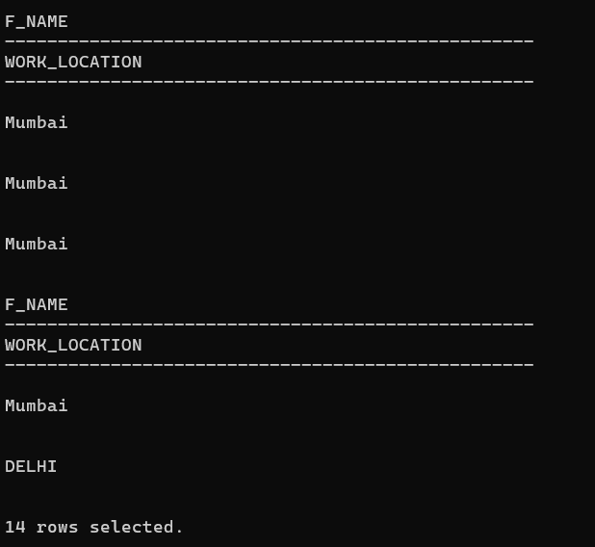

**28. Display the employees f_name and their work location after joining employee and**

**department table using full join/full outer join.**

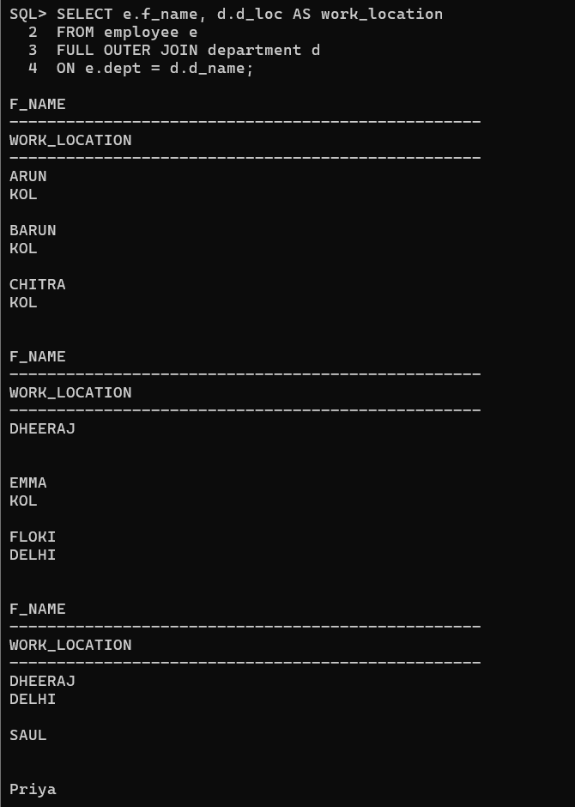

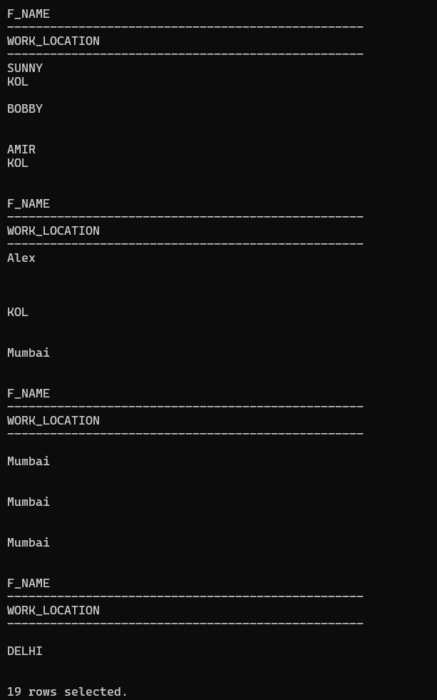

1. **Find the employees who are working in their home city.**

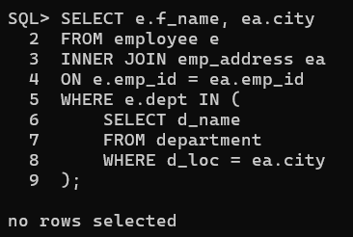

1. **Find the job type having the minimum average salary according to jobtypes.**

